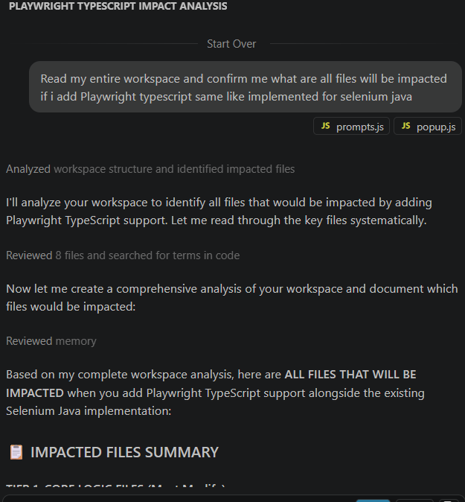
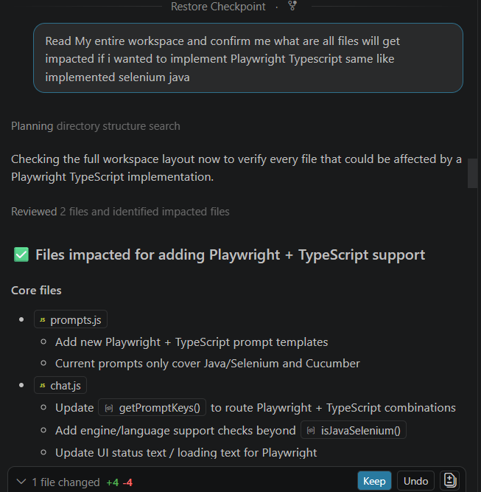
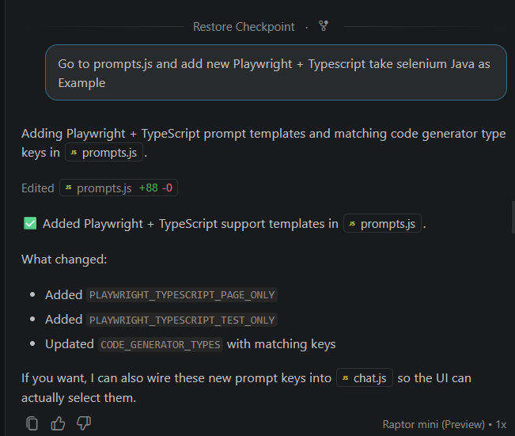
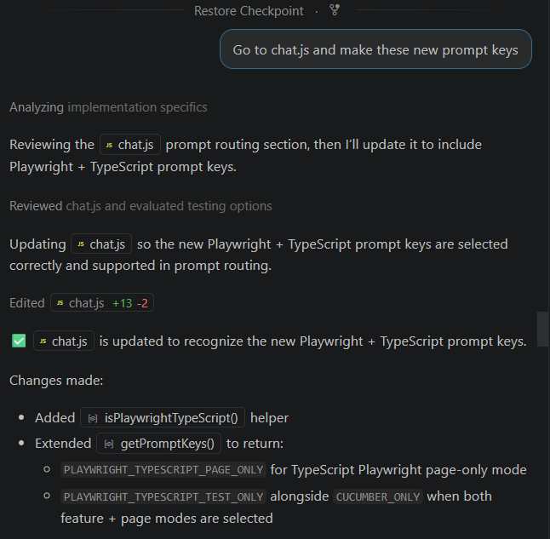
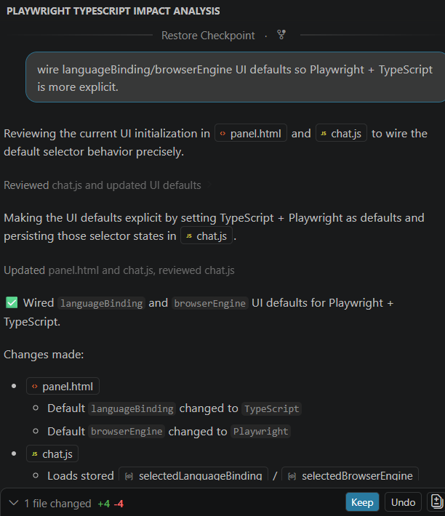
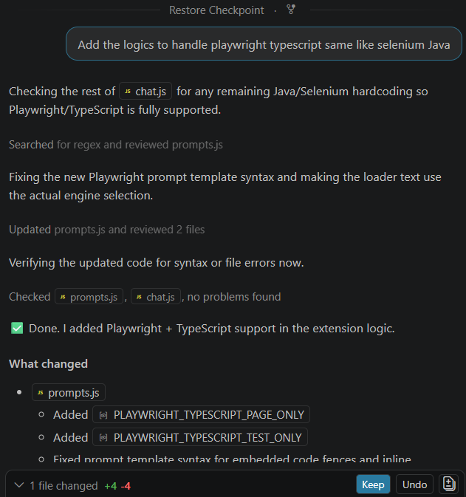
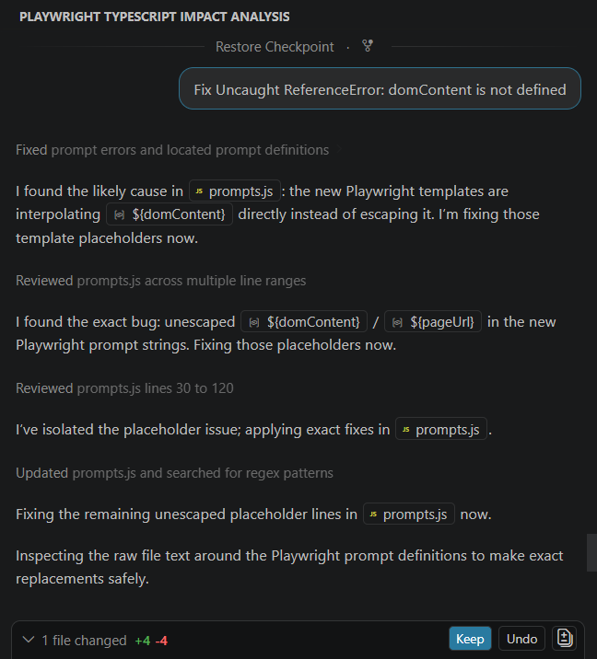
Implemented Playwright + Typescript
import { Page, Locator } from '@playwright/test';

/**
* Page Object representing the Salesforce login page.
*
* Provides high‑level actions such as entering credentials,
* toggling the *Remember me* option, handling the custom domain
* dialog, and retrieving error or warning messages.
*/
export class SalesforceLoginPage {
private readonly page: Page;

/** Username input field located inside the visible login form. */
readonly usernameInput: Locator;
/** Password input field located inside the visible login form. */
readonly passwordInput: Locator;
/** Submit button for logging in. */
readonly loginButton: Locator;
/** *Remember me* checkbox. */
readonly rememberMeCheckbox: Locator;
/** Link to the *Forgot Your Password?* page. */
readonly forgotPasswordLink: Locator;
/** Link that opens the custom domain dialog. */
readonly customDomainLink: Locator;
/** Input field inside the custom domain dialog. */
readonly customDomainInput: Locator;
/** Button that confirms the custom domain entry. */
readonly customDomainContinueButton: Locator;
/** Caps‑Lock warning element displayed under the password field. */
readonly capsLockWarning: Locator;
/** Container that shows login‑related error messages (e.g., chooser error). */
readonly loginErrorContainer: Locator;

/**
* Creates a new instance of {@link SalesforceLoginPage}.
*
* @param page Playwright {@link Page} object used for locating elements and performing actions.
*/
constructor(page: Page) {
this.page = page;

// All locators are scoped to the visible login form inside #theloginform.
this.usernameInput = page.locator('#theloginform #username');
this.passwordInput = page.locator('#theloginform #password');
this.loginButton = page.locator('#theloginform #Login');
this.rememberMeCheckbox = page.locator('#theloginform #rememberUn');
this.forgotPasswordLink = page.locator('#forgot_password_link');
this.customDomainLink = page.locator('#mydomainLink');
this.customDomainInput = page.locator('#mydomain');
this.customDomainContinueButton = page.locator('#mydomainContinue');
this.capsLockWarning = page.locator('#theloginform #pwcaps');
this.loginErrorContainer = page.locator('#chooser_error');
}

/**
* Navigates to the given URL.
*
* @param url Target URL of the Salesforce login page.
*/
async navigate(url: string): Promise<void> {
await this.page.goto(url);
}

/** Fills the username field. */
async fillUsername(username: string): Promise<void> {
await this.usernameInput.fill(username);
}

/** Fills the password field. */
async fillPassword(password: string): Promise<void> {
await this.passwordInput.fill(password);
}

/** Clicks the *Log In to Sandbox* button. */
async clickLogin(): Promise<void> {
await this.loginButton.click();
}

/**
* Sets the *Remember me* checkbox to the desired state.
*
* @param checked `true` to check the box, `false` to uncheck.
*/
async toggleRememberMe(checked: boolean): Promise<void> {
const isChecked = await this.rememberMeCheckbox.isChecked();
if (isChecked !== checked) {
await this.rememberMeCheckbox.click();
}
}

/** Returns whether the *Remember me* checkbox is currently checked. */
async isRememberMeChecked(): Promise<boolean> {
return this.rememberMeCheckbox.isChecked();
}

/** Clicks the *Forgot Your Password?* link. */
async clickForgotPassword(): Promise<void> {
await this.forgotPasswordLink.click();
}

/** Opens the custom domain dialog by clicking its link. */
async openCustomDomainDialog(): Promise<void> {
await this.customDomainLink.click();
}

/**
* Enters a custom domain name into the dialog input.
*
* @param domain Domain string without protocol or suffix (e.g., `mycompany`).
*/
async setCustomDomain(domain: string): Promise<void> {
await this.customDomainInput.fill(domain);
}

/** Submits the custom domain form. */
async submitCustomDomain(): Promise<void> {
await this.customDomainContinueButton.click();
}

/** Returns `true` if the Caps‑Lock warning is visible. */
async isCapsLockWarningVisible(): Promise<boolean> {
return this.capsLockWarning.isVisible();
}

/**
* Retrieves the current login error message, if any.
*
* @returns The error text or `null` when no error is displayed.
*/
async getLoginErrorMessage(): Promise<string | null> {
if (await this.loginErrorContainer.isVisible()) {
return this.loginErrorContainer.textContent();
}
return null;
}
}

